Selection Criteria:

* Strong intruder recognition
* Ease of design
* Low cost
* Control over driving
* Ability to stay within boundaries
* Disc accuracy
* Low power consumption
* Driving speed

Encoder Feedback Model

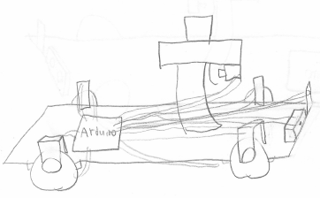

This design uses encoders attached to each wheel to know the robot’s exact movements at all times and stay within a designated range of the starting position. A solenoid pulls the trigger on a disc gun to fire the discs. Wheels are driven by individual servos. Intruders are detected with an IR sensor then scanned with a color sensor to determine if they are friend or foe.

QTI Boundaries Model

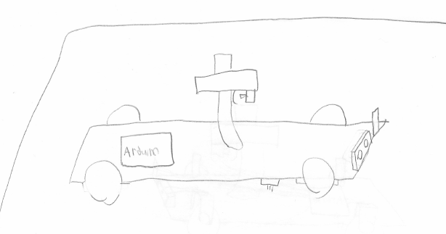

This design uses a QTI sensor to stay within a taped off boundary. A solenoid pulls the trigger on a disc gun to fire the discs. The front two wheels are controlled by servos. An ultrasonic sensor is mounted to detect intruders. A color sensor is mounted to differentiate friend from foe.

Walled in Model

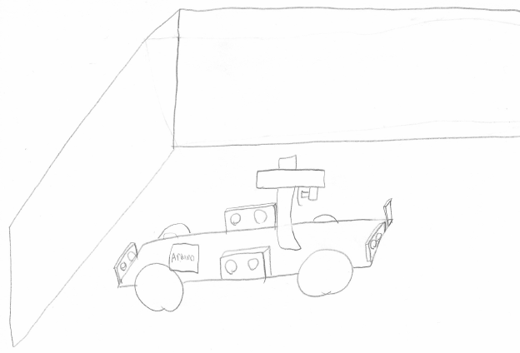

This design uses four side mounted ultrasonic sensors to detect the robot’s location within a walled off area and any intruders within that area. A solenoid pulls the trigger on a disc gun to fire the discs. The front two wheels are driven by individual stepper motors. A color sensor is mounted to differentiate friendly colored objects from unfriendly colored objects.